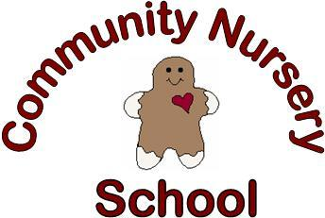

Community Nursery School
Registration Form 2019-2020
Child’s Name_________________________________________Birthdate__________________

Parent(s) Names________________________________________________________________

Phone Number_____________________________Cell_________________________________

Street________________________________________________________________________

City________________ Zip_____________ Email_____________________________________
Class Choice (Circle One)
3 & young 4 year-old classes
-Must be 3 by Sept. 1 or 4 on or after June 1 & potty trained
$450 per semester
Monday/Wednesday
8:45-11:15 A.M.
Tuesday/Thursday
8:45-11:15 A.M.
**Parent Signature______________________________________________________________
(**Please note age and potty training requirements.)
Return this form and the non-refundable $75 registration fee. (payable to Community Nursery School) to Community Nursery School, 740 E. College Ave., Appleton, WI 54911
Please note that there will be a $30 per semester supply fee for the 3&4 yr. old classes.

CNS Use Only:_________________________________________________________________________
Non-refundable Reg. Fee: Amount:_______________Date:____________Check#:___________

